**Smart Manufacturing Practice Report**

**Mechanical Design**

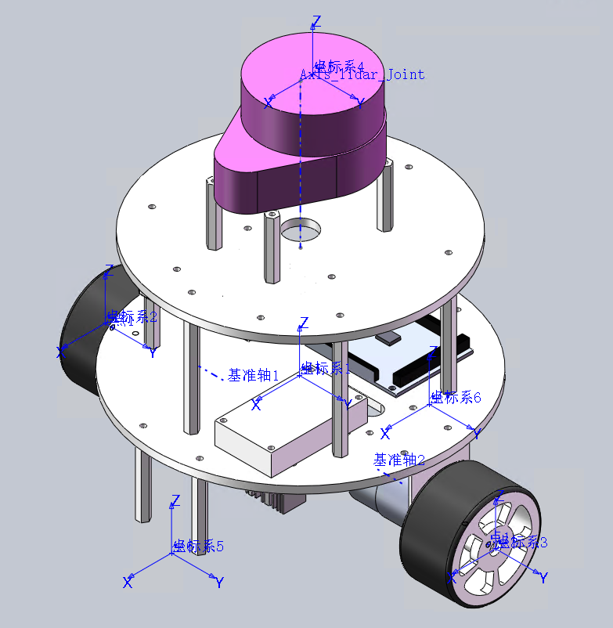

The designed car contains 2 layers of platform, holding the relative electronic components, the car is designed in a circular shape, allowing it to easily rotate with two motors and wheels. Maximizing its agility.

**Electronic Component**

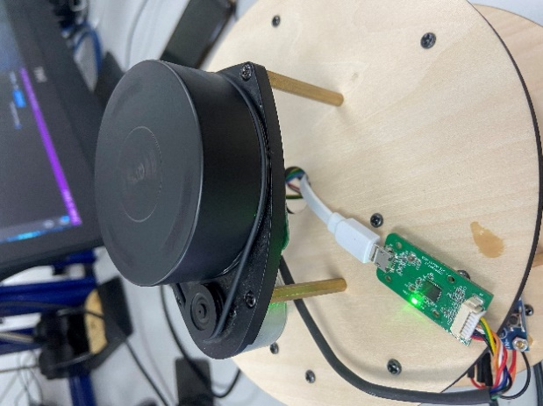 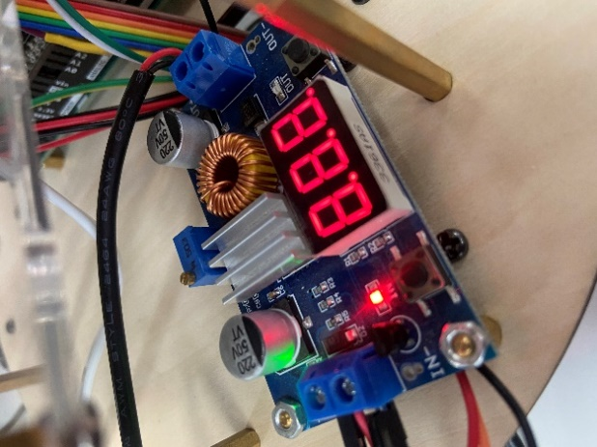

Rplidar Voltage adjustment

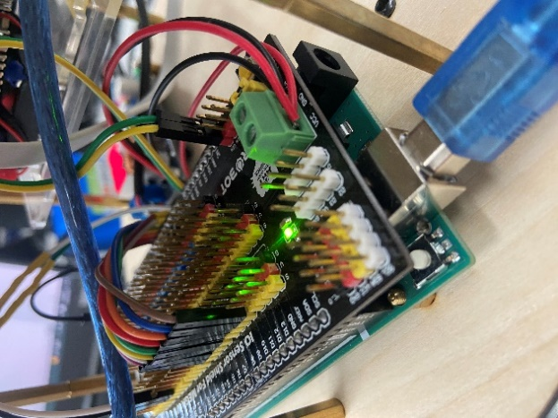 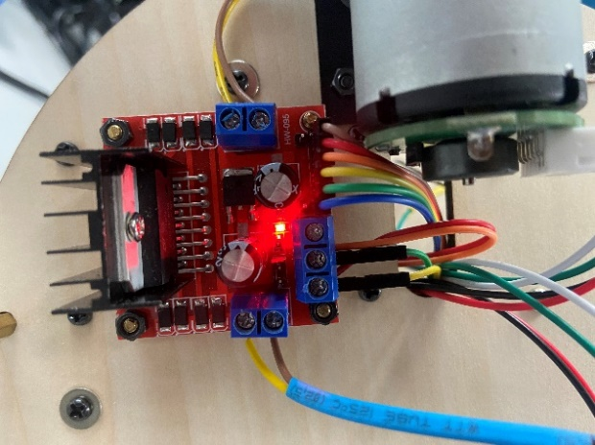

Arduino with extended board L298N

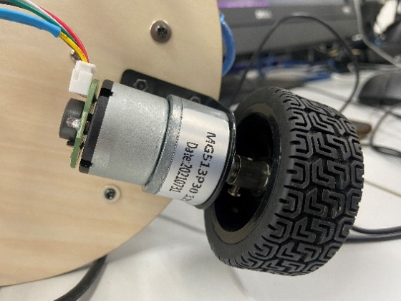 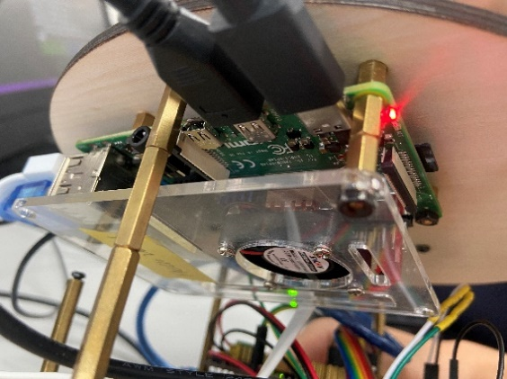

motor*2 rasbarry pie